MINI PROJECT REPORT
ON
“FLIPKART PRODUCT REVIEW SENTIMENT ANALYSIS”
Submitted in Partial fulfilment of the requirements for the award of
Bachelor of Technology (B.Tech)
In the department of
Computer Science & Engineering

Submitted by:
Chayan Ghosh (UG/02/BTCSEAIML/2022/002)
Rijwanool Karim (UG/02/BTCSEAIML/2022/004)
Shouryadip Bera (UG/02/BTCSE/2022/065)
Sk Mahiduzzaman (UG/02/BTCSEAIML/2022/005)
Sayantan Saha (UG/02/BTCSE/2022/003)
Sohel Khan (UG/02/BTCSE/2022/073)
Under the Guidance of
Mr. Aninda Kundu
School of Engineering & Technology
ADAMAS University, Kolkata, West Bengal Jan 2025 – May 2025

CERTIFICATE
This is to certify that the project report entitled “Flipkart Product Review Sentiment Analysis”, submitted to the School of Engineering & Technology (SOET), ADAMAS UNIVERSITY, KOLKATA in partial fulfilment for the completion of Semester – 7th of the degree of Bachelor of Technology in the department of Computer Science & Engineering, is a record of Bonafide work carried out by:- Chayan Ghosh (UG/02/BTCSEAIML/2022/002) ,Rijwanool Karim (UG/02/BTCSEAIML/2022/004)
Shouryadip Bera (UG/02/BTCSE/2022/065) , Sk Mahiduzzaman (UG/02/BTCSEAIML/2022/004) , Sayantan Saha (UG/02/BTCSE/2022/003) , Sohel Khan (UG/02/BTCSE/2022/073)
All help received by us from various sources has been duly acknowledged.
No part of this report has been submitted elsewhere for award of any other degree.

_______________
Aninda Kundu
Guide Name
________________
Aninda Kundu
(Project Coordinator)
________________
Dr. Sajal Saha
(HOD CSE)

ACKNOWLEDGMENT
The satisfaction and euphoria that accompany the successful completion of any task would be incomplete without mentioning the people whose constant guidance and encouragement made it possible. We take pleasure in presenting before you our project, which is the result of a studied blend of both research and knowledge.

We express our earnest gratitude to our Aninda Kundu (Guide designation), Department of CSE, for their constant support, encouragement and guidance. We are grateful for their cooperation and valuable suggestions.

Finally, we express our gratitude to all other members who are involved either directly or indirectly in the completion of this project.

DECLARATION
We, the undersigned, declare that the project entitled “Flipkart Product Review Sentiment Analysis”, being submitted in partial fulfillment for the award of Bachelor of Engineering Degree in Computer Science & Engineering, affiliated to ADAMAS University, is the work carried out by us.

__________________________ _____________________________
Chayan Ghosh Rijwanool Karim
(UG/02/BTCSEAIML/2022/002) (UG/02/BTCSEAIML/2022/004)

_____________________________ __________________________
Shouryadip Bera Sk Mahiduzzaman
(UG/02/BTCSE/2022/065) (UG/02/BTCSEAIML/2022/004)

____________________________ ____________________________ Sayantan Saha Sohel Khan
(UG/02/BTCSE/2022/003) (UG/02/BTCSE/2022/073)

ABSTRACT
The Sentiment Analysis for Product Reviews project focuses on developing an AI/ML-powered system to analyze customer feedback in the form of textual product reviews. The aim is to determine the overall sentiment—positive, negative, or neutral—expressed by customers about a product. This insight can help businesses improve their offerings, enhance customer satisfaction, and make data-driven decisions.
The goal of this project is to develop a system that allows customers to submit a shopping link for a desired product. The system will analyse the overall reviews of the product and generate a comprehensive report. Based on this analysis, the system will provide a recommendation to the customer on whether they should purchase the product or not, ensuring they make a profitable decision and avoid wasting money by selecting the best product.

TABLE OF CONTENTS
CHAPTER | TITLE | PAGE
 | FLIPKART PRODUCT REVIEW SENTIMENT ANALYSIS | 1
 | CERTIFICATE | 2
 | ACKNOWLEDGEMENT | 3
 | DECLARATION | 4
 | ABSTRACT | 5
 | TABLE OF CONTENTS | 6
 | LIST OF FIGURES | 8
 | LIST OF TABLES | 9
1 | INTRODUCTION | 10-13
 | 1.1 Background
 | 1.2 Purpose of the project
 | 1.3 Problem Statement
 | 1.4 Objective
 | 1.5 Structure of project
2 | LITERATURE REVIEW | 14 - 17
 | 2.1 Introduction
 | 2.2 Studies on Flipkart or Similar E-commerce Platforms
 | 2.3 Challenges in Scraping Flipkart Data
 | 2.4 Machine Learning & NLP Techniques Used (LSTM Focused)
 | 2.5 Handling Language, Noise, and Data Preprocessing
 | 2.6 Identified Gaps in Previous Research
 | 2.7 Comparison of Existing Approaches and Models
 | 2.8 Conclusion
3 | TECHNOLOGY USED | 18-25
 | 3.1 Introduction
 | 3.2 Web Scrapping Techniques
 | 3.3 Sentiment Analysis
 | 3.4 TensorFlow GPU
4 | METHODOLOGY | 26-33
 | 4.1 Web Scrapping
 | 4.2 Data Preprocessing
 | 4.3 Deep Learning Approach
 | 4.4 Transformer Approach
5 | OUTPUT | 34-35
 | 5.1 Table of all Models
 | 5.2 Confusion matrix of final model with final statement.
6 | CONCLUSION | 36
7 | FUTURE ASPECT | 37-38
8 | REFERENCE | 39

LIST OF FIGURES
FIGURE | TITLE | PAGE
Figure 1.1 | WORKFLOW OF THE PROJECT | 13
Figure 3.1 | BERT ARCHITECTURE | 23
Figure 4.3.1.1 | RNN WITH GLOVE LOSS AND ACCURACY GRAPH | 28
Figure 4.3.2.1 | LSTM WITH GLOVE LOSS AND ACCURACY GRAPH | 29
Figure 4.3.3.1 | BILTSM WITH GLOVE LOSS AND ACCURACY GRAPH | 31
Figure 4.3.4.1 | BILSTM WITH DOC2VEC LOSS AND ACCURACY GRAPH | 32
Figure 4.4.1.1 | BERT ACCURACY AND LOSS GRAPH | 33
Figure 5.2.1 | CONFUSION MATRIX OF FINAL MODEL | 35

LIST OF TABLES
TABLE NO. | TITLE | PAGE
Table no. 4.3.1.1 | RNN with glove DL architecture | 27
Table no. 4.3.2.1 | LSTM with glove embedding DL architecture | 28-29
Table no. 4.3.3.1 | BILSTM with glove embedding DL architecture | 30-31
Table no. 4.4.1.1 | BERT architecture | 33
Table no. 5.1.1 | Comparison with all model output | 34-35

1. INTRODUCTION
1.1 Background of the Project
In today’s world people use online shopping for almost everything, from clothes to electronics. But the product quality is not always as expected and value for money, so some time the user doesn't get value for money product and waste their hard-earned money. That’s why before buying a product, customers often check reviews to see what others think about the product quality. But read all the reviews one by one and analyse them is time-consuming and haptic for users.so we use sentiment analyse and web scrapping technology to automate the process for the users so that the users can analyse the product quality in one click.
In today's world Flipkart is one of the biggest e-commerce platforms in India. So, we build the project for Flipkart’s product analyse. Users can simply paste the review link of the product, and the website fetch the product review and get the positive, negative and neutral reviews so users can easily decide whether the product is value for money or not.
Here we use sentiment analysis, which is a smart technology that helps by automatically understanding whether a review is positive, negative, or neutral. It uses Artificial Intelligence and Natural Language Processing (NLP) to analyse customer reviews.
By studying Flipkart product reviews using sentiment analysis, we can classify the positive, negative and neutral reviews in different categories. This information is useful for both shopkeepers and customers. Users can make better buying decisions, and companies can improve their products quality and services.

1.2 Purpose of the Project
The main goal of Flipkart Product Review Sentiment Analysis is to understand what customers think about different products by analysing their reviews. Since there are thousands of reviews on Flipkart, it is impossible to read all of them manually. Sentiment analysis helps by automatically identifying whether a review is positive, negative, or neutral.
Why is it useful?
- Helps Customers Choose Better Products –: Buyers can quickly see if most people like or dislike a product before making a purchase.
- Improves Product Quality: Companies can find out common complaints and make better products based on customer feedback.
- Enhances Customer Experience: Businesses can use reviews to improve their service and make shopping easier for customers.
- Understands Market Trends: Companies can see which products are popular and what features customers like the most.
- By using sentiment analysis, Flipkart, sellers, and customers all benefit. It makes online shopping easier, helps companies improve their products, and ensures a better experience for everyone.
- Save time of user: User give the review url in our website and our website provide them the sentiment analysis of the product and it help them to reduce time to read all review manually.
- Automates Review Analysis: Here user provide the review link, and it automatically fetch the review.
1.3 Problem Statement
Nowadays, people believe in online shopping for almost everything, from clothes to electronics. But not all products meet expectations, and sometimes buyers end up wasting their hard-earned money. To avoid this, customers they must check reviews before purchasing. However, reading and analysing numerous reviews can be time-consuming. This project aims to simplify the process by using web scraping to collect reviews and sentiment analysis to summarize them, helping users quickly understand product quality with just one click.
Sentiment analysis is a technology that helps in understanding customer opinions automatically. It uses Artificial Intelligence (AI) and Natural Language Processing (NLP) to check whether a review is positive, negative, or neutral. This helps businesses know what customers like or dislike about a product.
For Flipkart, analysing product reviews using sentiment analysis can help in many ways. Customers can quickly find the best products based on positive feedback, while businesses can use this information to improve their products and services. This automated process saves time, provides useful insights, and helps both buyers and sellers in making better decisions.

1.4 Objective
The main objective of Flipkart Product Review Sentiment Analysis is to analyse customer feedback automatically. Since Flipkart has millions of product reviews, manually reading and understanding them is not practical. Sentiment analysis helps classify these reviews as positive, negative, or neutral, making it easier for customers to make their decisions.
Key Objectives: -
- Understand Customer Opinions – Identify whether customers are satisfied, dissatisfied, or neutral about a product.
- Help Customers Make Better Decisions – Provide quick insights into product quality based on past customer experiences.
- Improve Product and Service Quality – Enable businesses to recognize and address common complaints and issues.
- Save Time with Automated Analysis – Use AI to analyse large volumes of reviews quickly and efficiently.
- Track Customer Satisfaction Trends – Monitor how customer opinions change over time for specific products.
- Enhance Personalized Recommendations – Improve Flipkart’s recommendation system by prioritizing well-reviewed products.
- Reduce Product Return Rates – Identify and fix issues in poorly reviewed products, leading to fewer returns.
- Strengthen Brand Reputation – Help businesses maintain a good reputation by addressing negative feedback and improving customer satisfaction.

1.5 Structure of project
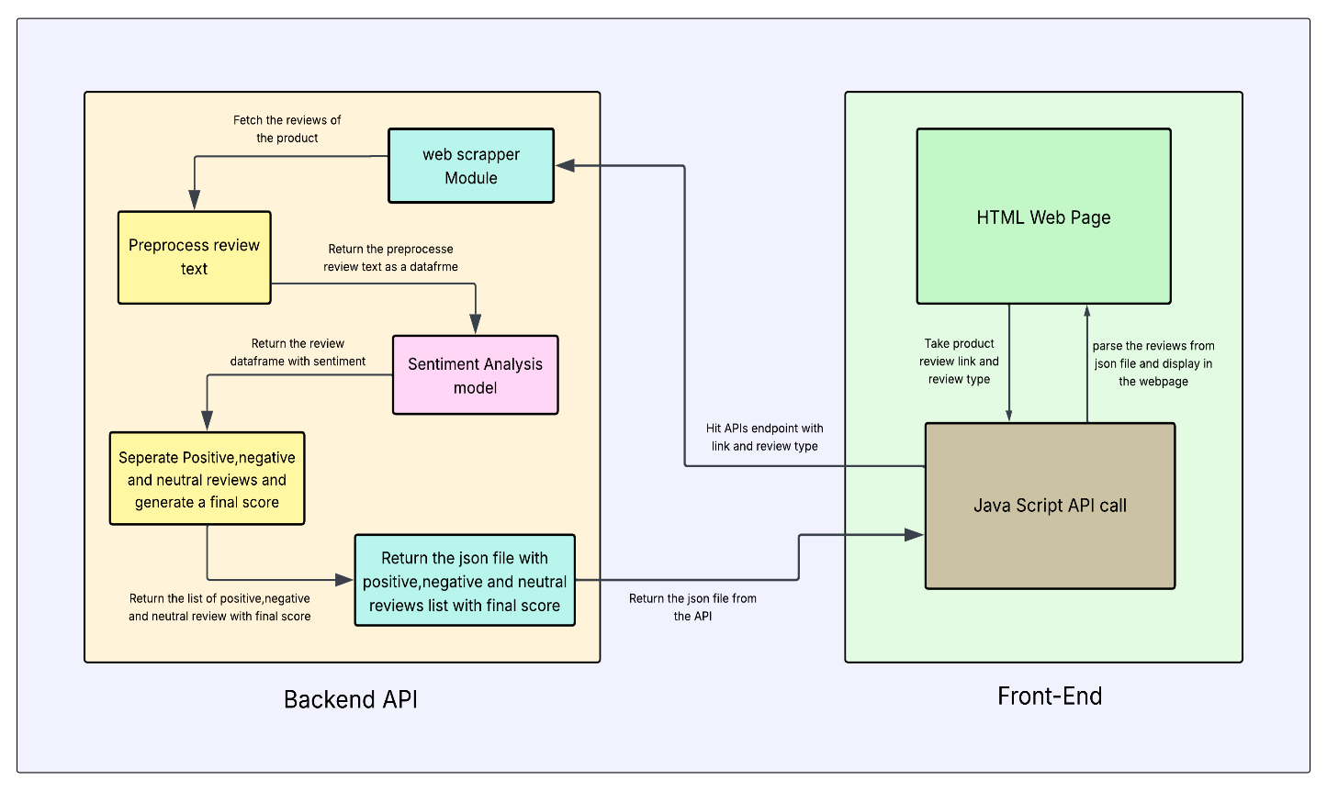 Fig 1.1 WORK-FLOW OF THE PROJECT

2. LITERATURE REVIEW
2.1Introduction
This study explores the use of web scraping and sentiment analysis to extract and evaluate customer reviews from Flipkart. By analysing review sentiments using machine learning techniques, businesses can gain valuable insights into consumer preferences, helping improve product quality, customer service, and marketing strategies.

2.2 Studies on Flipkart or Similar E-commerce Platforms
Several studies have focused on sentiment analysis using review data from e-commerce platforms like Amazon, Flipkart, and Snapdeal. Research on Flipkart is relatively newer but growing, with studies investigating sentiment polarity, feature-based opinion mining, and review summarization. Many researchers use publicly available datasets or extract data via web scraping to train sentiment classifiers. Studies often compare Indian e-commerce data with global platforms to understand differences in user behaviour and language usage. Research has also highlighted challenges unique to platforms like Flipkart, such as multilingual reviews, code-mixed text (e.g., Hinglish), and shorter or less-informative reviews. These studies provide a foundation for developing customized models that better understand regional and linguistic nuances specific to the Indian market. [ 1 ]

2.3 Challenges in Scraping Flipkart Data
Scraping data from Flipkart presents several technical and legal challenges. The platform often uses dynamic content loading with JavaScript, which makes traditional scraping tools like ‘requests’ and ‘BeautifulSoup’ less effective. Instead, tools like Selenium or Puppeteer are required to render content. Flipkart’s frequent changes in HTML structure, use of anti-bot mechanisms (like CAPTCHAs), and rate limiting can disrupt the scraping process. Furthermore, legal and ethical issues arise due to the terms of service, which may prohibit scraping. Additionally, maintaining data accuracy and consistency is difficult as product listings, prices, and reviews are continuously updated. These factors make Flipkart scraping a non-trivial task requiring robust technical solutions and ethical considerations. [ 2 ]

2.4 Machine Learning & NLP Techniques Used (LSTM Focused)
Long Short-Term Memory (LSTM) networks are a type of recurrent neural network (RNN) particularly effective for sentiment analysis of product reviews. Unlike traditional RNNs, LSTMs are capable of learning long-term dependencies, making them well-suited for understanding the context and flow of language in user reviews. This is crucial in sentiment analysis, where the sentiment of a sentence often depends on the sequence of words. LSTM models can handle varying review lengths and remember key features across long text inputs, which is a common challenge in e-commerce data like Flipkart reviews. Combined with preprocessing techniques such as tokenization and lemmatization, LSTMs can process clean text to identify sentiment patterns. Embedding layers like Word2Vec or Glove are often used to convert text into vector form before feeding into the LSTM. Overall, LSTM models provide high accuracy and contextual understanding, making them a strong choice for analysing product sentiments.

2.4.1 Literature Review Deep Learning Techniques in Sentiment Analysis:
Discuss the application of deep learning models, particularly Recurrent Neural Networks (RNNs) and Long Short-Term Memory (LSTM) networks, in classifying sentiments.
Example: Deep learning models like RNNs and LSTMs have been effectively utilized for sentiment classification tasks, capturing the sequential nature of textual data. [ 3 ]
2.4.2 Methodology Model Architecture:
Describe the architecture of the LSTM model used for sentiment classification, emphasizing its ability to capture long-term dependencies in text.
Example: The LSTM model processes input sequences to capture long-range dependencies, making it suitable for sentiment analysis tasks.
2.4.3 Results Performance Metrics:
Present the accuracy achieved by the LSTM model in classifying sentiments -
arXiv +1 arXiv +1
Example: The LSTM model achieved an accuracy of 88.47% for binary sentiment classification, demonstrating its effectiveness in distinguishing between positive and negative emotions.
2.4.4 Discussion Emotion Subclassification:
Explain the further classification of positive and negative sentiments into specific emotions.
Example: Beyond binary classification, the model categorized positive emotions into enthusiasm, fun, happiness, love, relief, and surprise, and negative emotions into anger, boredom, hate, sadness, and worry.
2.4.5 Conclusion Implications and Future Work:
Discuss the implications of using deep learning models for sentiment analysis and potential areas for future research.
Example: The application of LSTM networks in sentiment analysis showcases the potential of deep learning in understanding complex emotional expressions in text. Future work could explore the integration of multimodal data to enhance emotion recognition accuracy. [ 4 ]

2.5 Handling Language, Noise, and Data Preprocessing
User-generated reviews are often noisy, containing spelling mistakes, emojis, abbreviations, and code-mixed language (e.g., Hinglish). Handling this noise is crucial for accurate sentiment classification. Preprocessing techniques such as removing HTML tags, special characters, and stop words help in cleaning the text. Tokenization and lemmatization further simplify linguistic structure. For handling mixed-language text, translation tools or multilingual NLP models like BERT are used. Slang and informal expressions are often addressed with domain-specific dictionaries. Noise reduction not only improves model accuracy but also ensures the sentiment captured truly reflects user intent. Effective preprocessing is therefore a critical step in transforming raw Flipkart review data into usable input for machine learning models. [ 5 ]

2.6 Identified Gaps in Previous Research
While significant progress has been made in sentiment analysis, several research gaps remain, especially concerning Indian e-commerce platforms like Flipkart. Many existing studies rely on English-only data, ignoring the multilingual and informal nature of Indian consumer reviews. Few works address real-time sentiment monitoring or the scalability of models when applied to large datasets. Another gap lies in combining structured data (ratings, features) with unstructured review text for more holistic sentiment analysis. Additionally, sarcasm detection, fake review identification, and aspect-based sentiment analysis are underexplored in this context. These gaps offer opportunities for further research that addresses the unique linguistic, cultural, and technical challenges of analysing Flipkart product reviews.

2.7 Comparison of Existing Approaches and Models
Existing sentiment analysis approaches vary in complexity and effectiveness. Traditional machine learning models like Naïve Bayes and SVM are faster to train and easier to interpret but often lack contextual understanding. In contrast, deep learning models like LSTM and BERT provide higher accuracy due to their ability to understand context and long-term dependencies in text. Rule-based systems, though useful in specific domains, struggle with scalability and generalization. When applied to e-commerce reviews, especially in a platform like Flipkart with informal and mixed-language content, deep learning models tend to outperform others. However, they also require more computational resources and labelled data. Hybrid models that combine rule-based and learning-based approaches are emerging as promising solutions for more robust sentiment analysis across diverse datasets. [ 6 ]

2.8 Conclusion
Web scraping and sentiment analysis of Flipkart reviews provide meaningful insights into customer opinions. By leveraging techniques like LSTM and proper preprocessing, accurate sentiment classification is achievable. This literature review highlights existing approaches, challenges, and gaps, offering a foundation for future research in e-commerce sentiment analysis.
3. TECHNOLOGY USED
3.1 Introduction
Overview
This project automates the analysis of customer reviews from Flipkart, classifying them as positive, negative, or neutral using advanced technologies. We utilize BeautifulSoup4 for web scraping and BERT for sentiment detection.

Key Technologies Used

1. Natural Language Processing (NLP)
NLP enables computers to understand and interpret human language in customer reviews.

Techniques Used:
- Tokenization – Splitting text into meaningful units.
- Lemmatization – Converting words to their base forms.
- Stop-word Removal – Removing common words that do not add value.
- Named Entity Recognition (NER) – Identifying proper nouns, brands, etc.
- Part-of-Speech (POS) Tagging – Categorizing words based on grammar.

2. Deep Learning
Advanced AI models help in accurately detecting sentiment by analyzing complex sentence structures.

Models Used:
- Recurrent Neural Networks (RNN)
- Long Short-Term Memory (LSTM)
- Bi-directional LSTM (Bi-LSTM)
- Transformers (BERT)

3. Text Processing Libraries
These libraries help in cleaning and analyzing text data.
Examples:
- NLTK (Natural Language Toolkit)
- spacy

4. Text Embedding Techniques
Vectorization techniques are used to convert text into numerical representations for machine learning models.
Examples:
- Glove
- Doc2Vec
- Word2Vec

5. Web Scraping Techniques
We use BeautifulSoup4, a Python library, to extract customer reviews from Flipkart web pages and store them in a Data Frame for sentiment analysis.

6. Front-End Technologies
The user interface is built with:
- HTML & CSS – For website structure and styling.
- JavaScript – For interactivity and backend API calls.

3.2 Web scrapping Techniques
In this project, web scraping was employed to automatically extract customer reviews from Flipkart product pages. The scraping process was implemented using Python’s requests and Beautiful Soup libraries.
- Target Website: As our website is only focused on the Flipkart product review analysis. So, Flipkart product review pages were chosen as the data source. Each review page contains user-submitted reviews about products, which we extract for sentiment analysis.

- Pagination Handling: In one page there are not enough reviews. So, to gather enough reviews about the product, the scraper navigates through multiple pages one by one using a loop and collects reviews from multiple pages. By default, the max page limit is set to 10 but we can dynamically modify the page number in the URL.

- HTML Parsing: Specific HTML classes corresponding to review containers were identified by inspecting Flipkart’s webpage structure. By using the class name, we extract the review text. Flipkart uses two types of review layouts (single and multiple). In single reviews there is only one main review text, so can we directly extract the review. But in multiple review types there is main system generate heading for every review and under this the main customer review is present, so we ignore the system generated review and only extract the user review. For this reason, we use two separate functions to ensure reliable scraping and prevent any errors while fetching.

- Data Cleaning: Reviews often contain unwanted strings such as “READ MORE” or line breaks (\n). These were cleaned using basic string operations (replace (), strip ()). Duplicate reviews or empty strings were filtered out before storing the data. So that we get the correct reviews for sentiment analysis.

- Error Handling: Robust error handling was implemented to manage network issues or structural changes on the website. Pages without reviews or malformed elements are safely skipped. We also use regex for URL validation, so that no one can input wrong URL.

- Output Format: The extracted reviews are cleaned (e.g., removal of “READ MORE” fragments) and stored in a pandas Data Frame for further processing.
This scrapping mechanism provides a scalable and automated way to collect real-world user opinions, forming the foundational dataset for sentiment analysis in this project. This is one of the important steps in our project.
3.3 Sentiment analysis:

3.3.1 What is BERT?
BERT language model is an open-source machine learning framework for natural language processing (NLP). BERT is designed to help computers understand the meaning of ambiguous language in text by using surrounding text to establish context. The BERT framework was pretrained using text from Wikipedia and can be fine-tuned with question-and-answer data sets.
BERT, which stands for Bidirectional Encoder Representations from Transformers, is based on transformers, a deep learning model in which every output element is connected to every input element, and the weightings between them are dynamically calculated based upon their connection.
Historically, language models could only read input text sequentially -- either left-to-right or right-to-left -- but couldn't do both at the same time. BERT is different because it's designed to read in both directions at once. The introduction of transformer models enabled this capability, which is known as bidirectionality. Using bidirectionality, BERT is pretrained on two different but related NLP tasks: masked language modeling (MLM) and next sentence prediction (NSP).
The objective of MLM training is to hide a word in a sentence and then have the program predict what word has been hidden based on the hidden word's context. The objective of NSP training is to have the program predict whether two given sentences have a logical, sequential connection or whether their relationship is simply random.

3.3.2 How BERT works
The goal of any given NLP technique is to understand human language as it is spoken naturally. In BERT's case, this means predicting a word in a blank. To do this, models typically train using a large repository of specialized, labeled training data. This process involves linguists doing laborious manual data labeling.
BERT, however, was pretrained using only a collection of unlabeled, plain text, namely the entirety of English Wikipedia and the Brown Corpus. It continues to learn through unsupervised learning from unlabeled text and improves even as it's being used in practical applications such as Google search. BERT's pretraining serves as a base layer of knowledge from which it can build its responses. From there, BERT can adapt to the ever-growing body of searchable content and queries, and it can be fine-tuned to a user's specifications. This process is known as transfer learning. Aside from this pretraining process, BERT has multiple other aspects it relies on to function as intended. [ 7 ]
3.3.3 Why We Use BERT?
In this project we need a model of those whose perform better than LSTM and BI-LSTM. So, after LSTM or BI-LSTM the best method is self-attention for NLP. Here we need an encoder only model because we only perform sentiment analysis that contextual understanding of a sentence does not need any text generator.
Key features of BERT:-
1. Contextual Understanding
- BERT understands the context of words in a sentence by considering both left and right context (bidirectional learning).
- Unlike traditional models like Word2Vec or LSTM, which process text sequentially, BERT reads the entire sentence at once, improving sentiment detection.
2. Handles Complex Sentences
- Customer reviews often have sarcasm, negations, or mixed sentiments (e.g. "The phone is good, but the battery is terrible.").
- BERT captures these subtleties better than traditional models like LSTMs or simple machine learning classifiers.
3. Pre-Trained on Large Datasets
- BERT is pre-trained on massive text data (like Wikipedia & Book Corpus), making it highly effective for text-based tasks with minimal training.
- You can fine-tune BERT on your Flipkart review dataset to improve performance.
4. Works Well with Short & Long Reviews
- Many reviews are short ("Great product!") or long ("The camera is amazing, but the software has bugs.").
- BERT efficiently handles both concise and detailed reviews.
5. Outperforms Traditional Models
- Compared to RNNs, LSTMs, and Bidirectional LSTM BERT achieves higher accuracy in sentiment classification.
This is because it understands relationships between words more effectively
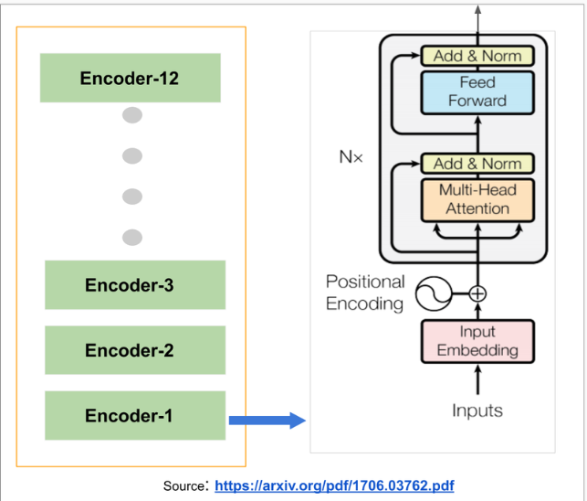Fig 3.1 BERT ARCHITECTURE

3.4 TensorFlow GPU
3.4.1 What is Tensor GPU
TensorFlow-GPU is a version of the TensorFlow machine learning framework optimized for using NVIDIA GPUs (Graphics Processing Units) to accelerate training and inference of machine learning models. TensorFlow-GPU leverages the parallel processing capabilities of NVIDIA GPUs to significantly speed up the training and execution of machine learning models.
3.4.2 Benefits of using TensorFlow GPU

1. Faster Training and Inference
- GPU acceleration significantly speeds up the training of deep learning models.
- Especially helpful for models with large word embeddings or long text sequences.
- Reduces the time taken for both training and making predictions, enabling quicker iterations.

2. Efficient Handling of Complex Models
- Sentiment analysis with LSTM, GRU, or Transformer-based models (like BERT) involves many matrix operations — GPUs are optimized for this.
- Using a GPU makes it easier to train deeper and more accurate models without waiting for hours or days.

3. Scalability
- With TensorFlow GPU, your model can be trained on larger datasets and larger batches, helping improve generalization.
- Better suited for real-time applications where speed is crucial (e.g., live sentiment monitoring on social media).

4. Seamless Integration with TensorFlow Ecosystem
- TensorFlow automatically detects and utilizes available GPUs.
- You can switch between CPU and GPU without changing much code — just install tensorflow-gpu.

5. Support for Pre-trained Models
- Many powerful pre-trained models (e.g., BERT, RoBERTa) are GPU-optimized, which speeds up fine-tuning and inference for sentiment analysis tasks.
3.4.3 How to use TensorFlow-GPU
1. You need an NVIDIA GPU with CUDA support. Make sure you have the necessary GPU drivers installed.
2. Install the TensorFlow-GPU package (or the combined TensorFlow package that includes GPU support).
3. TensorFlow will automatically use the GPU if it's available and configured properly.

4 Methodology
4.1 Web Scrapping
Here we are using BeautifulSoup for Web Scrapping Flipkart review from their page. Users provide the product review link in our website and this function fetch the reviews from website and returns it as a data frame.
4.2 Data-preprocessing
At first, we are doing the lower text then we convert it into tokenize form. Keep only alphameric works from sentence then we are creating one function that replace the emoji into readable names for this we are using python emoji library. Then we are removing the punctuation and steaming the whole sentence and return print and space separated string.
4.3 Deep Learning Approach
What is Deep Learning?
Deep learning is a type of machine learning that uses artificial neural networks to learn from data. Artificial neural networks are inspired by the human brain, and they can be used to solve a wide variety of problems, including image recognition, natural language processing, and speech recognition.

How does deep learning work?

Deep learning works by using artificial neural networks to learn from data. Neural networks are made up of layers of interconnected nodes, and each node is responsible for learning a specific feature of the data. Building on our previous example with images – in an image recognition network, the first layer of nodes might learn to identify edges, the second layer might learn to identify shapes, and the third layer might learn to identify objects.
Data Preprocessing
As the network learns, the weights on the connections between the nodes are adjusted so that the network can better classify the data. This process is called training, and it can be done using a variety of techniques, such as supervised learning, unsupervised learning, and reinforcement learning.
Once a neural network has been trained, it can be used to make predictions with new data it’s received.

Deep learning vs. machine learning
Both deep learning and machine learning are branches of artificial intelligence, with machine learning being a broader term encompassing various techniques, including deep learning. Both machine learning and deep learning algorithms can be trained on labelled or unlabelled data, depending on the task and algorithm.
Machine learning and deep learning are both applicable to tasks such as image recognition, speech recognition, and natural language processing. However, deep learning often outperforms traditional machine learning in complex pattern recognition tasks like image classification and object detection due to its ability to learn hierarchical representations of data.
4.3.1 RNN with Glove embedding
Here we are using glove embedding technique for vectorize our text. Then we are feeding our text in traditional architecture. Our all details of RNN model present in our below table

Title: RNN with glove DL architecture
Layer(type) | Output Shape | Parameter
Embedding (Embedding) | (None, 400,100) | 1,057,000
Simple_rnn (SimpleRNN) | (None, 400,128) | 29,312
Dropout (Dropout) | None, 400,128 | 0
Simple_rnn_1(SimpleRNN) | (None, 64) | 12,352
Dropout_1(Dropout) | None, 64) | 0
Dense (Dense) | (None,3) | 195
Table no. 4.3.1.1
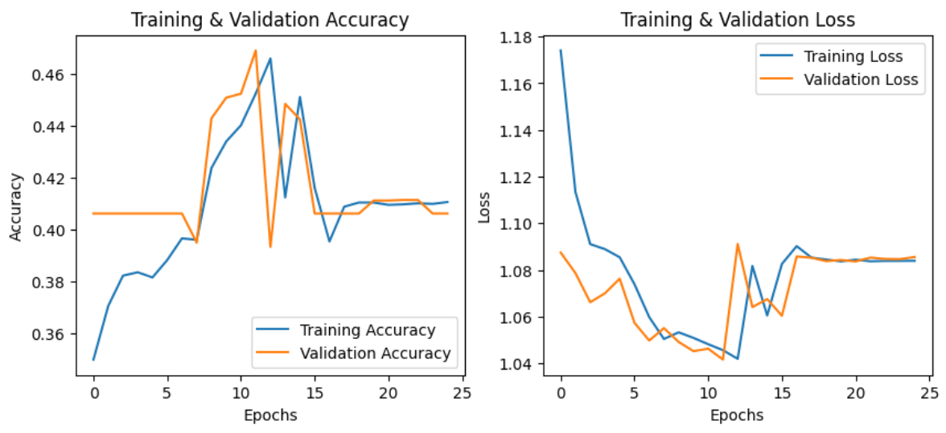 Fig: 4.3.1.1 RNN WITH GLOVE LOSS AND ACCURACY GRAPH
Here we clearly see our model is under-fit, so we are trying one another model with same embedding technique.
4.3.2 LSTM with Glove Embedding
To overcome the vanishing gradient problem in traditional Recurrent Neural Networks (RNNs), we use Long Short-Term Memory (LSTM) networks. Unlike standard RNNs, LSTMs are built to handle long-term dependencies in sequences more effectively. At the heart of an LSTM is a memory cell, which acts like a storage unit that can hold important information over time.
This memory is managed by three key components called gates:
- The input gate decides what new information should be added to the memory.
- The forget gate chooses what old or unnecessary information should be removed.
- The output gate controls what information from the memory should be passed on to the next step.
Here is our LSTM architecture details in below table: -
Title: LSTM with glove embedding DL architecture
Layer(type) | Output Shape | Parameter
Embedding (Embedding) | (None, 400,100) | 1,057,000
lstm (LSTM) | (None, 400,128) | 117,248
Dropout (Dropout) | None, 400,128 | 0
lstm_1(LSTM) | (None, 128) | 131,584
Dropout_1(Dropout) | None, 128) | 0
Dense (Dense) | (None,3) | 387
Table no. 4.3.2.1
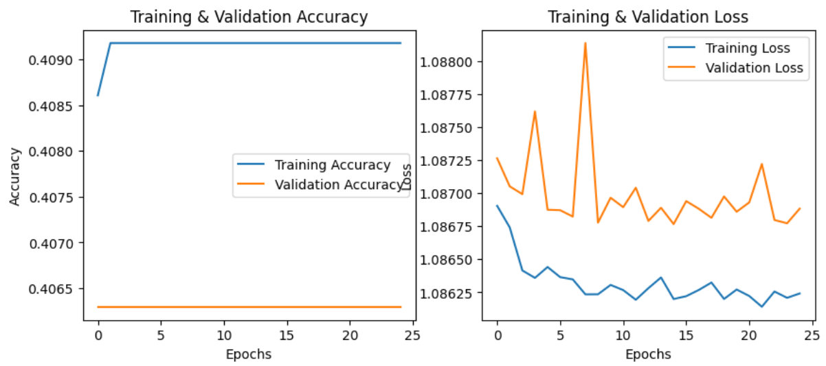 Fig: 4.3.2.1 LSTM WITH GLOVE LOSS AND ACCURACY GRAPH

Here we see that this is also an under-fit model. So, after this result we are trying same embedding techniques with Bidirectional LSTM.
4.3.3 Bidirectional LSTM with Glove Embedding
A Bidirectional LSTM, or BILSTM, is a sequence processing model that consists of two LSTMs: one taking the input in a forward direction, and the other in a backwards direction. BILSTMs effectively increase the amount of information available to the network, improving the context available to the algorithm. [ 8 ]
Why are we going for bi-directional LSTM?
When analysing Flipkart product reviews for sentiment analysis, we often go for a bi-directional LSTM (Bi-LSTM) because of the way it understands context from both directions — forward and backward.

1. Context from Both Sides
- Example review: "The phone is not bad."
- A regular LSTM reading left to right might catch "not", but it might miss the subtle implication that "not bad" means "good".

2. Better Handling of Complex Sentences
- Product reviews often include contrasts or comparisons:
  - "The design is amazing, but the battery life is disappointing."

3. Improved Accuracy
- Studies and benchmarks show that Bi-LSTM models typically perform better in classification tasks like sentiment analysis, due to their more comprehensive understanding of the sentence structure.

4. Natural Language Isn’t One-Way
- In real-life text, meaning often depends on what comes after a word as much as what comes before.
  - “Only” in “I only like the camera” changes the sentiment drastically.
- Bi-LSTM captures this bidirectional dependency well.

For benefit of BILSTM we feed our data to this model to check our model performance is increased or not. Here we are using same embedding technique. In below table we provide our model architecture: -
Title: BILSTM with glove embedding DL architecture
Layer(type) | Output Shape | Parameter
embedding_1 (Embedding) | (None, 400,100) | 1,056,700
bidirectional_2 (Bidirectional) | (None, 400,128) | 84,480
Dropout (Dropout) | None, 400,128 | 0
bidirectional_3(Bidirectional) | (None, 128) | 98,816
dropout_3(Dropout) | None, 128) | 0
dense_1 (Dense) | (None,3) | 387
Table no. 4.3.3.1
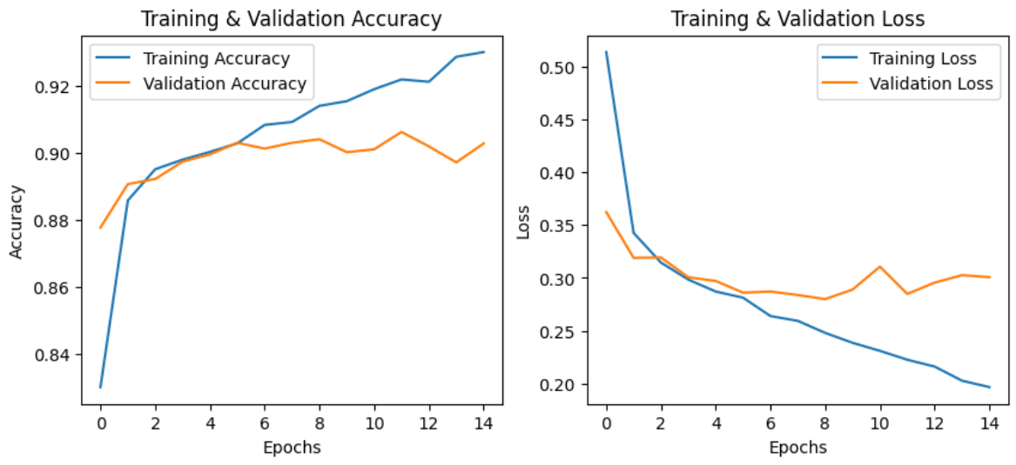 Fig: 4.3.3.1 BILTSM WITH GLOVE LOSS AND ACCURACY GRAPH
Here we see that for both directional understanding of a sentence our model understands the contextual of the sentence and provide better result in our project. But here main problem is, it does not provide good result to our test dataset, so we change the embedding technique. Now we use a sentence based on embedding technique named Doc2vec.
4.3.4 Bidirectional LSTM with Doc2vec
Purpose of Doc2Vec
Converts whole documents/reviews into dense vectors (fixed length).Good for capturing semantic meaning of entire texts.
Pretrained Embeddings (like Word2Vec, Glove):
- Use predefined vectors for each word.
- Require mapping every word in the dataset to its corresponding vector.
- Often lose the document-level structure (only word-level embeddings).
- Dimensionality is based on word vectors, not the original dataset size.
Doc2Vec:
- Trains a model to generate vectors for entire documents, not just words.
- Maintains the same number of vectors as the number of documents.
- Helps preserve context and semantics at the document level.
- Dataset dimensionality remains unchanged—each document gets one fixed-size vector.
Here our architecture is same as previous model but some changes in accuracy and loss.
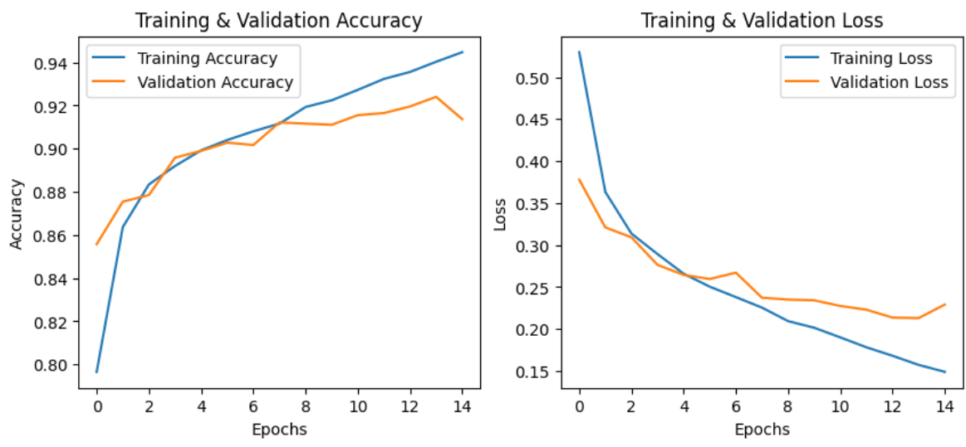Fig: 4.3.4.1 BILSTM WITH DOC2VEC LOSSAND ACCURACY GRAPH
Although the model performs well on both the training and test datasets, it shows signs of bias. It accurately identifies positive reviews but struggles to correctly classify neutral and negative ones. We are now generating synthetic data to reduce the bias in our dataset, however, it still does not yield the level of accuracy we were expecting.
4.4 Transformer Approach
4.4.1 Bidirectional Encoder Representations from Transformers(BERT)
In our research to find a more suitable model for our project, we came across a technique called self-attention, which is known for delivering strong results in Natural Language Processing tasks. This technique is a core component of the transformer architecture. Based on this, we decided to use an encoder-only transformer model called BERT (Bidirectional Encoder Representations from Transformers). Developed by Google, BERT is a powerful open-source language model renowned for its ability to understand the context of words within a sentence.
Due to system limitations, we are using a smaller variant of BERT, as our hardware is not capable of handling the larger models.
It is the architecture of smaller variant of BERT.
Title: BERT architecture
Table no. 4.4.1.1
Layer(type) | Output Shape | Parameter
bert (TFBertMainLayer) | multiple | 109482240
dropout_37 (Dropout) | multiple | 0 (unused)
classifier (Dense) | multiple | 2307
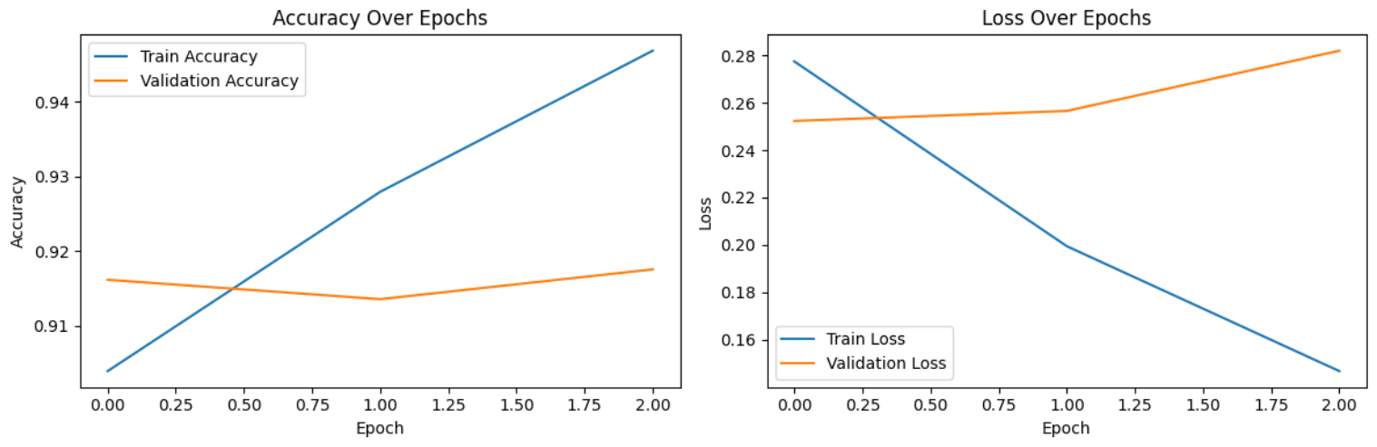Fig: 4.4.1.1 BERT ACCURACY AND LOSS GRAPH

Since BERT is a pretrained model developed by Google, we are fine-tuning it to suit our specific task. It has delivered good accuracy on both our training and test datasets. Therefore, we have decided to select this model for our project. We tested the model in various ways, and it consistently performed up to the mark.

5 OUTPUT
5.1 Output table of all models
Title: Comparison with all model output
Model name | Embedding technique | Accuracy | Validation Accuracy | Validation loss | Conclusion
RNN | Doc2Vec | 0.81 | 0.815 | 0.58 | Due to biasness in our dataset our model gives positive result.
LSTM | Doc2Vec | 0.81 | 0.815 | 0.58 | Due to biasness in our dataset our model gives positive result.
BILSTM | Doc2Vec | 0.94 | 0.91 | 0.22 | While the model shows good accuracy on paper, its performance on the test dataset falls short of expectations.
BILSTM | Word2Vec | 0.94 | 0.80 | 0.52 | This model is slightly overfit.
RNN | Glove | 0.40 | 0.40 | 1.08 | It is a underfit model.
LSTM | Glove | 0.41 | 0.40 | 1.08 | It is a underfit model.
BILSTM | Glove | 0.92 | 0.90 | 0.28 | While the model shows good accuracy on paper, its performance on the test dataset falls short of expectations.
BERT | BERT | 0.9696 | 0.9103 | 0.3324 | It delivers good accuracy and performs well on our test dataset.
Table no. 5.1.1

5.2 Confusion matrix of final model with final statement
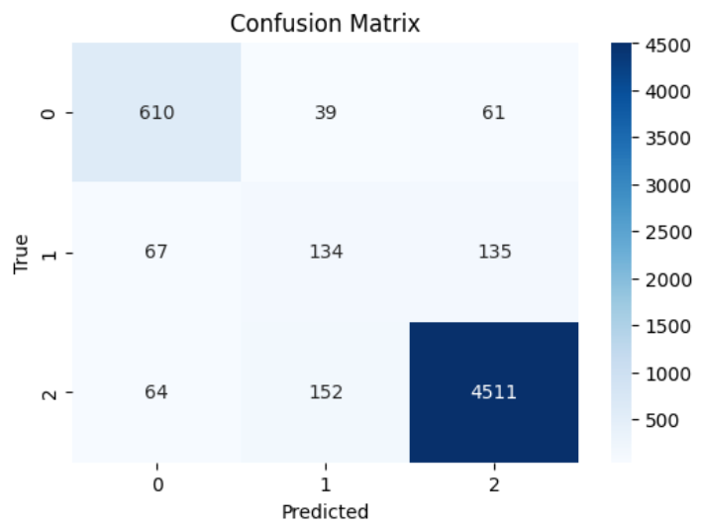Fig: 5.2.1 Confusion Matrix of final model

It is clear that our model performs well on the test dataset. Although it shows some limitations in handling neutral reviews, the overall performance is still satisfactory.

6. CONCLUSIONS
In this project we use web scrapping technique, flask APIs and multiple models with embedding technique for analysis the review sentiment but some model like simple RNN, LSTM and BILSTM are giving not expected accuracy and misclassify the reviews, so we move toward a better approach, finally we use BERT, which stands for Bidirectional Encoder Representations from Transformers, is based on transformers, a deep learning model in which every output element is connected to every input element, and the weightings between them are dynamically calculated based upon their connection . BERT gives us much better result and accuracy compared to previous model, but some time it confuses between positive and neutral reviews because we use the lower version of BERT. Due to lack of resources and computational powers we are not able to use higher version of BERT for more accurate result. But, in future we upgrade our existing model with higher version so that the review classification is more accurate, and number of misclassifications is reduced. We also plan to improve our UI design and the speed of the process for better user interactions and user satisfactions. In future we also add more useful features in this website also and extend user base and give a better solution to users.

7. FUTURE ASPECT
As we discuss in conclusion section that we have some problem in the projects like our model's accuracy is good but not too much high, currently the model confuses between some reviews and some misclassifications happen. Also, our UI is not as expected and the time of fetch and analysis the review is also little slow. So, what we want to improve in future is as bellow
- Improve The Sentiment Model: Currently we train a lower version of BERT in a comparatively small dataset, that's why the accuracy is not as expect and our model do some misclassifications, so in future we use a large dataset for training the BART model and we also upgrade to a higher parameter BERT for better result and sentiment detection , as the model is the backbone of our project so it is the main improvement which we do in future .

- Improve Web Page Design: Currently our web page is useable but not completely user friendly and the colour palate is also not very visually appealing. So, for better user experience which is important. So, after improving the model we must improve the web page design also.

- Add Product Recommendation: In future we plan to add a new future along with the product analyse feature. When the user submits a product link for analyse then the product report is generated and there is recommendation section which suggest user the similar product with better positive review and better score. It helps user to chouse a better and value for money product without less efforts. It reduces the user time to find a better product. Unfortunately, this feature is not available, but we try to add this feature as soon as possible.

- Improve the speed: In current project the speed is little slow, when the user submits and press the analyse button the Backend API takes few times to fetch and classify the product review due to lower computational power, but when we deploy the website and API in the server then the speed will be improved and we also make some changes into the API workflow so that the speed improves.

- Add Trending feature list: In future we also store the record of which product link is analyse by the user how many times, we use the data to predict the trending product in current market, it is a valuable data for business to manage their product inventory and also it can help to predict the market trend of the a specific product . It also helps to identify the good products and bad products, using this data product manufacturers can improve their product quality and services. Basically, this feature is helping the shopkeepers and manufacturers along with the customers. This feature improves the website diversity and increase the targeted audience's space.

8 REFERENCES
[1]. Adarsh Kumar , K N Ganesh , “SENTIMENTAL ANALYSIS ON FLIPKART PRODUCT BASED ON CUSTOMER REVIEW “
[2]. Scraping Ant Team , “ Overcoming data scraping challenges with Web Scraping API”
[3]. Neeraj Anand Sharma1, A. B. M. Shawkat Ali Muhammad , Ashad Kabir “ A review of sentiment analysis: tasks, applications, and deep learning
Techniques”
[4]. Shilpa P C , Rissa Shereen , Susmi Jacob , Vinod P ,” SENTIMENT ANALYSIS USING DEEP LEARNING ”
[5]. Medium , “Cleaning Up the Noise: Essential Text Preprocessing Techniques for NLP”
[6]. Cemile Gokce Ozmen, Selim Gunduz, “Comparison of Machine Learning Models for Sentimental Analysis of Big Turkish Web-based Data”
[7]. Cameron Hashemi-Pour, Ben Lutkevich, “BERT language Model”
[8]. Paperswithcode ,“Bidirectional LSTM”

